17.96: a) The capstan is doing work on the rope at a rate
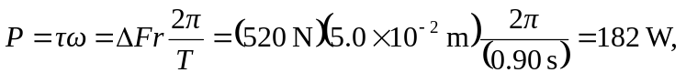
or  to two figures. The net torque that the rope exerts on the capstan, and hence the net torque that the capstan exerts on the rope, is the difference between the forces of the ends times the radius. A larger number of turns might increase the force, but for given forces, the torque is independent of the number of turns.
b) 